УО «Белорусский государственный университет информатики и радиоэлектроники»

Кафедра ПОИТ

Отчёт по лабораторной работе №5

По предмету

Базы данных

Выполнил:

Гладкий М.Г.

Проверил:

Фадеева Е.Е.

Группа 851005

Минск 2021

Предметная область: Интернет-магазин компьютерных игр

Даталогическая модель:

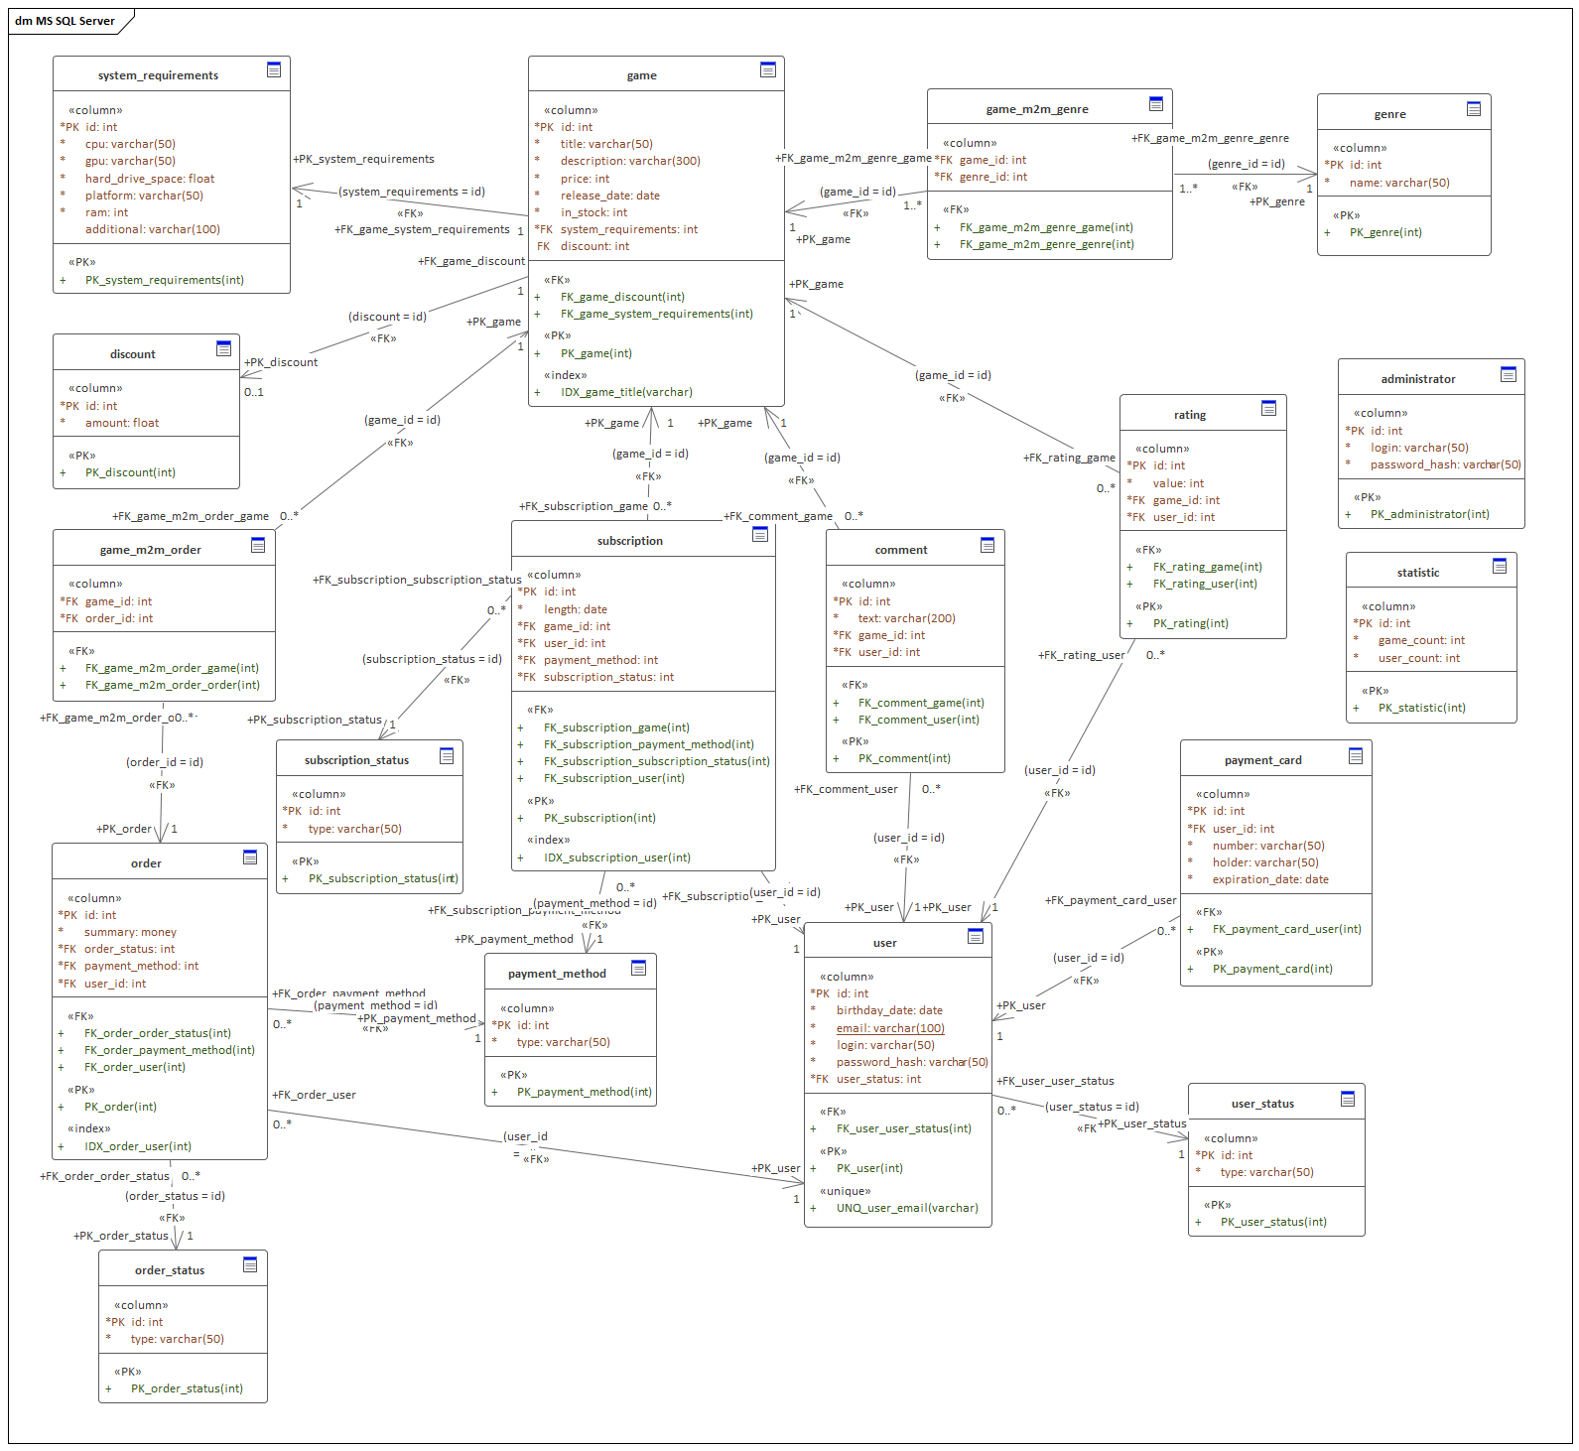

1) Права доступа:

Были созданы следующие роли: Администратор, Модератор, Пользователь, Гость. Далее прилагается SQL-код для настройки:

--Administrator

DROP USER IF EXIST `administrator`@`localhost`;

CREATE USER ` administrator `@`localhost` IDENTIFIED BY <complex password>;

GRANT ALL PRIVILEGES ON * TO `administrator `@`localhost`;

--Moderator

DROP USER IF EXIST `moderator`@`localhost`;

CREATE USER `moderator`@`localhost` IDENTIFIED BY <complex password>

GRANT INSERT, SELECT, UPDATE, DELETE ON `comment ` TO 'moderator'@'localhost';

GRANT SELECT ON `rating` TO 'moderator'@'localhost';

GRANT SELECT ON `subscription` TO 'moderator'@'localhost';

GRANT SELECT, UPDATE ON `subscription_status` TO 'moderator'@'localhost';

GRANT SELECT ON `order` TO 'moderator'@'localhost';

GRANT SELECT, UPDATE ON `order_status` TO 'moderator'@'localhost';

GRANT INSERT, SELECT, UPDATE, DELETE ON `game` TO 'moderator'@'localhost';

GRANT SELECT, UPDATE ON `game_m2m_order` TO 'moderator'@'localhost';

GRANT SELECT, UPDATE ON `system_requirements ` TO 'moderator'@'localhost';

GRANT INSERT, SELECT, UPDATE, DELETE ON `genre` TO 'moderator'@'localhost';

GRANT SELECT, UPDATE ON `game_m2m_genre` TO 'moderator'@'localhost';

GRANT INSERT, SELECT, UPDATE, DELETE ON `discount` TO 'moderator'@'localhost';

GRANT SELECT ON `payment_method` TO 'moderator'@'localhost';

GRANT SELECT ON `user` TO 'moderator'@'localhost';

GRANT SELECT, UPDATE ON `user_status` TO 'moderator'@'localhost';

GRANT INSERT, SELECT, UPDATE, DELETE ON `statistic` TO 'moderator'@'localhost';

--User

DROP USER IF EXISTS 'user'@'localhost';

CREATE USER 'user'@'localhost' IDENTIFIED BY '<complex password>';

GRANT SELECT ON `comment ` TO 'user'@'localhost';

GRANT SELECT ON `rating` TO 'user'@'localhost';

GRANT SELECT ON `subscription` TO 'user'@'localhost';

GRANT SELECT ON `subscription_status` TO 'user'@'localhost';

GRANT SELECT ON `order` TO 'user'@'localhost';

GRANT SELECT ON `order_status` TO 'user'@'localhost';

GRANT SELECT ON `game` TO 'user'@'localhost';

GRANT SELECT ON `game_m2m_order` TO 'user'@'localhost';

GRANT SELECT ON `system_requirements ` TO 'user'@'localhost';

GRANT SELECT ON `genre` TO 'user'@'localhost';

GRANT SELECT ON `game_m2m_genre` TO 'user'@'localhost';

GRANT SELECT ON `discount` TO 'user'@'localhost';

GRANT SELECT ON `payment_method` TO 'user'@'localhost';

GRANT SELECT ON `user` TO 'user'@'localhost';

GRANT SELECT ON `user_status` TO 'user'@'localhost';

GRANT SELECT ON `statistic` TO 'user'@'localhost';

--Guest

DROP USER IF EXISTS 'guest'@'localhost';

CREATE USER 'guest'@'localhost' IDENTIFIED BY '<complex password>';

GRANT SELECT ON `comment ` TO 'guest'@'localhost';

GRANT SELECT ON `rating` TO 'guest'@'localhost';

GRANT SELECT ON `subscription` TO 'guest'@'localhost';

GRANT SELECT ON `subscription_status` TO 'guest'@'localhost';

GRANT SELECT ON `order` TO 'guest'@'localhost';

GRANT SELECT ON `order_status` TO 'guest'@'localhost';

GRANT SELECT ON `game ` TO 'guest'@'localhost';

GRANT SELECT ON `game_m2m_order` TO 'guest'@'localhost';

GRANT SELECT ON `system_requirements ` TO 'guest'@'localhost';

GRANT SELECT ON `genre` TO 'guest'@'localhost';

GRANT SELECT ON `game_m2m_genre` TO 'guest'@'localhost';

GRANT SELECT ON `discount` TO 'guest'@'localhost';

GRANT SELECT ON `payment_method` TO 'guest'@'localhost';

GRANT SELECT ON `user` TO 'guest'@'localhost';

GRANT SELECT ON `user_status` TO 'guest'@'localhost';

GRANT SELECT ON `statistic` TO 'guest'@'localhost';

2) Кодировки:

Для всех отношений на диаграмме были добавлены тэги DEFAULT CHARACTER SET и COLLATE:

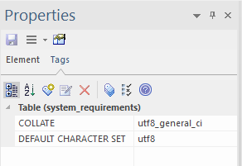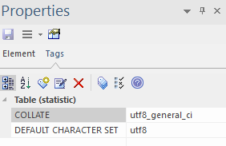

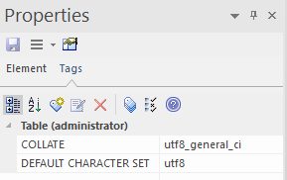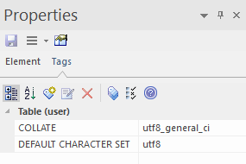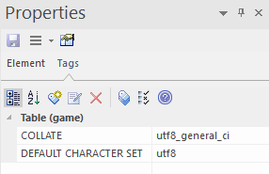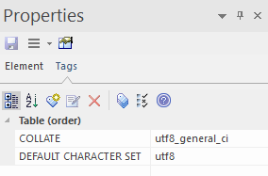

3) Метод доступа:

Для всех отношений на диаграмме был добавлен тэг ENGINE:

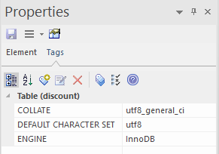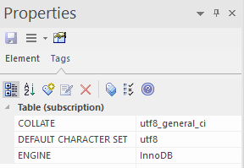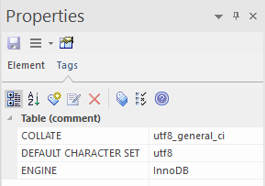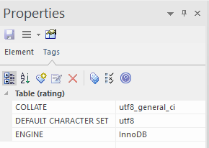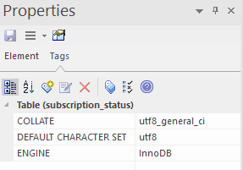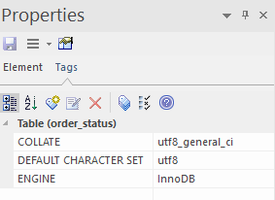

4) Индексы:

IDX_game_title – название игры у отношения game

IDX_order_user – id пользователя у отношения order

IDX_subscription_user – id пользователя у отношения subscription

UNQ_user_email – email пользователя у отношения user